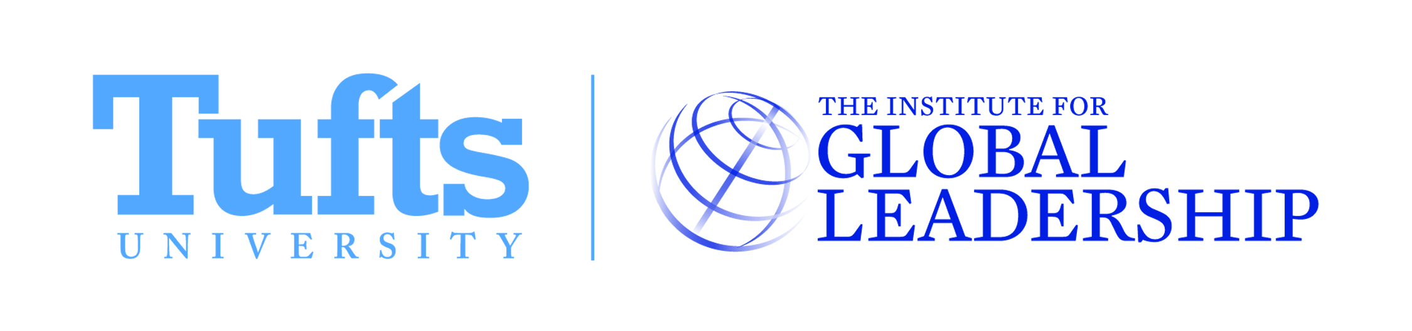
“Voices from the Field”
February 26th, 2015 || 9:00am-5:30pm || IGL, 3rd Floor, 96 Packard Ave

Main Theme: How does Russia’s search for great power status shape its engagement with the international community, and specifically its relations with the United States?

Sessions
1. Social (9:00-10:30am)
Goal: To explore the social motivations behind Russia’s decisions.

Questions:
How do national identity and the search for great power status shape each other?
How do different generations, both in the United States and in Russia, view Russia’s role in the international system?
How does the Internet affect all of the above issues, including the possibility of it putting pressure on leaders for “results”?

2. Political (10:30am-12:00pm)
Goal: To understand Russian and Western political interests and how they interact.

Questions:
What are Russia’s political interests?
How does the US view Russia in the international system, and why? How does Russia view the US in the international system and why? How do these mis/understandings affect relations?
What are Western interests in the region and how do they interact with Russian interests? How has this changed in light of recent events (i.e. Ukraine)? What common ground can be found? What are the challenges to effective communication?
Can Russia’s interests in the region be reconciled with the West’s? Will this always be an adversarial relationship?

3. Economic (1:00-2:30pm)
Goal: To understand how political and economic interests influence and drive each other in Russia.

Questions:
What actions is Russia taking in its effort to become a global economic power?
How will the westward shift of former Soviet republics affect Russia’s role in the global and regional economy?
How will Russia’s energy politics impact its economic viability in the future?

4. Strategic/Military (2:30-4:00pm)
Goal: To understand how political strategic interests manifest themselves militarily

Questions:
What role will Russia’s military play in the former Soviet republics? How will this affect those countries' relationship with the EU and overall security in the region?
How does perception of US and NATO affect Russia’s strategic considerations?
How does NATO presence in Russia’s desired “sphere of influence” affect Russia’s strategic interests?
What is Russia’s current and future role in the nuclear community?

5. Conclusion (4:00-5:30pm)
What policy recommendations can be derived from these discussions?

Participants
• Jeffrey Chamberlain, Global Threat Reduction Initiative, U.S. National Nuclear Security Administration, U.S. Department of Energy

• Mike Eckel, Writer and Editor, Voice of America, covering Russia’s annexation of Crimea and subsequent events; former Moscow Correspondent, Associated Press

• Ilya Lozovsky, Assistant Editor, Democracy Lab, Foreign Policy; former Program Officer, Freedom House

• Stephen Schmida, Co-Founder and Managing Director, SSG Advisers; former Regional Director, Russia and Central Asia, Eurasia Foundation; former Program Officer, National Democratic Institute

• Shorena Shaverdashvili (EPIIC’99), Partner and Editor, Liberali, Georgia

• Stephan Vitvitsky (EPIIC’06), International Economist, Office of Europe and Eurasia, U.S. Department of Treasury; Fulbright Research Scholar, Ukraine (mostly confirmed)

• Zach Witlin, Associate, Eurasia Group; former Alfa Fellow, Cargill, Moscow; Fulbright Research Scholar, Ukraine

