OSLO SCHOLARS PROGRAM - 2016

Speakers & Internships

All those interested are required to apply by 24th March 2016, 11.59 pm with the following materials submitted t0: scholars@oslofreedomforum.com
- Current CV/resume
- Cover Letter addressing your interest in the program, the specific speaker and summer internship you are applying for, and how you qualify for it
- Completed application form
- Writing sample

You are only eligible to attend the Forum if you apply for an internship with a 2016 speaker (as highlighted next to each speaker).

Oslo Scholars Program 2016 Application

Please ensure that you have handed in all additional materials for us to consider your application. This includes a cover letter, resume, and writing sample as well as the basic application form.

Part I: Basic Information
Name: | Major:
School: | Class Year:

Part II: Languages
Language 1: | Language 2: | Language 3:
Beginner | Beginner | Beginner
Proficient | Proficient | Proficient
Fluent | Fluent | Fluent

Part III: Personal and Academic References
Please list two personal references that we could contact, references who can attest to your academic capabilities, maturity, and professionalism.

Name: | Name:
Title: | Title:
Phone: | Phone:
Email: | Email:
Questions? Email scholars@oslofreedomforum.com with any questions concerning the application or the Oslo Scholars Program. We look forward to reading your applications!

Suleiman Bakhit (2016)

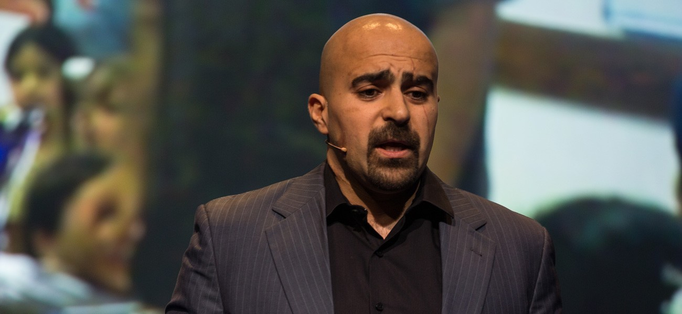

Suleiman Bakhit is a Jordanian social entrepreneur and best-selling comic book creator. Bakhit is the CEO of Aranim Media Factory, which sold 1.2 million comics in 2010. He is also the founder of the Hero-Factor project, an organization dedicated to promoting heroism as an antidote to extremism for Middle Eastern youth. Bakhit focuses his work on the development of stories, myths, and heroes that promote tolerance and counter a culture of extremism and discrimination against women and girls. Bakhit was motivated to create his company after experiencing discrimination in the U.S. after the 9/11 terrorist attacks. Bakhit is also a TED Global Fellow.

Internship

Location: Remote/possibility to meet in Boston or New York periodically
Description: Suleiman is working to expand his work and is launching his own nonprofit, calling the Heromakers Initiative. He has also recently signed an agreement with the Jordanian government to include his comic books in textbooks that will be distributed to every child in Jordan over the next five years. This is a pilot program that he hopes to expand to other Arab countries in the future. He is hard at work preparing new stories to include in this program. Because of security concerns, the student will not be able to work directly with Suleiman in Jordan. However, Suleiman makes trips frequently to the U.S., during which he can make plans to meet directly with the student in Boston or New York.

The student should:
- Be comfortable working remotely and using apps for communication (Google apps, messaging, Skype etc.)
- Be studying business development, communications, writing, digital media, or fine arts
- An interest or experience in nonprofit management
- Strong written communication skills in English, knowledge of Arabic a plus
- Commit a privacy agreement to not share their work with Suleiman publicly (because of security concerns) - no social media posting, etc.
- Be a self-starter and able to adapt easily to changing situations; entrepreneurial spirit

Alaa Murabit (2016)

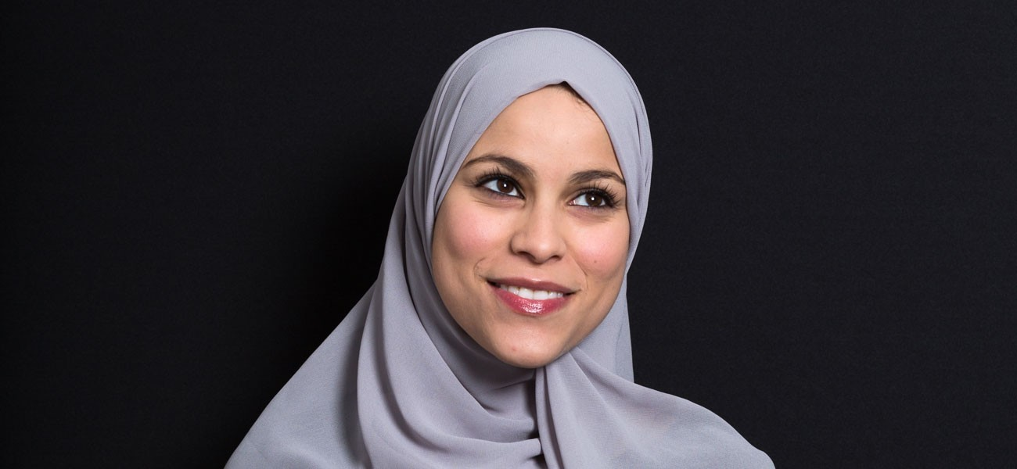

Alaa Murabit is a pediatrician and women’s rights activist who moved to Libya from Canada when she was 15 years old. While in medical school, Murabit became frustrated with the lack of women’s rights in her new home. After petitioning her university to allow women to sit on the student council, an illegal act at the time, she was placed on Gadhafi’s most wanted list. During the Libyan Revolution of 2011, Murabit founded the Voice of Libyan Women (VLW), an organization focused on empowering women economically and politically. Her programs, such as the groundbreaking “Noor Campaign,” have been replicated internationally. As violence has gripped Libya once again, VLW is working to increase women’s participation in the fight against extremism.

Murabit acts as advisor to numerous international security boards, think tanks, and organizations. Most recently she was nominated to the UN Security Council Resolution 1325 (women, peace and security) Global Advisory Board, the UN Women Global Advisory Board, and Harvard University’s “Everywoman, Everywhere” initiative. She was named the "International Trust Women Hero 2014" by The New York Times and "One of 25 Women Under 25 to Watch" by Newsweek.

Internship

Time frame: June through August (flexible)
Location: Remote because of security concerns, with the potential opportunity to meet with Alaa when she travels to the U.S. (probably in New York)
Description: This internship is with the Voice of Libyan Women.
- Intern must speak English, and knowledge of Arabic is preferred.
- Must be comfortable with communicating via Skype and phone calls while working remotely
- Student should have a good understanding of the historical context of the Middle East and be interested in women’s rights. Knowledge of women in peacebuilding/conflict is preferable.
- Intern should be research oriented with strong writing skills and a background in analysis.
- Student should have a working understanding of the UN and the UN system.

Ji Seong-ho (NAUH)

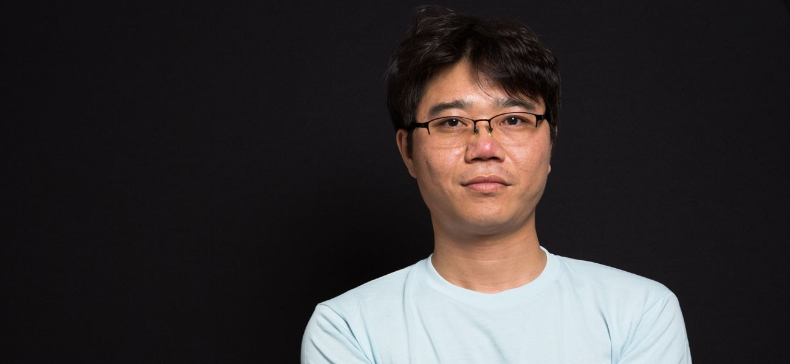

Ji Seong-ho is a North Korean defector who grew up during the country’s grueling famine in the 1990s. In order to survive, Ji would exchange stolen coal for food on the black market. While taking coal from a train car in 1996, a malnourished Ji lost consciousness and fell onto the tracks, losing his left hand and foot when a train ran over him. After a grueling amputation surgery, Ji was left to fend for himself. In 2006, he escaped to South Korea, where he is now a law student at Dongguk University. Ji is also the president of Now Action and Unity for Human Rights, where he helps broadcast information into North Korea and facilitates the resettlement of defectors in South Korea.

Internship

Time frame: July 1 - August 30
Location: Seoul
Description: Seong-ho has not previously worked with an intern from the U.S. and is very excited about the opportunity. His biggest goal for this year is setting up an English homepage for his organization, NAUH. He recently moved into a new office and is expanding the organization’s work of resettling disabled North Korean refugees as well as sending information into North Korea. Another potential project for the scholar is to help teach North Korean defectors English.
Qualifications:
- Student must speak Korean. Fluency is preferred, but if the student has a working knowledge of Korean that could also be acceptable.
- An interest in North Korean issues
- Experience translating Korean to English.
- Web/technical skills are a plus.
Justine Hardy

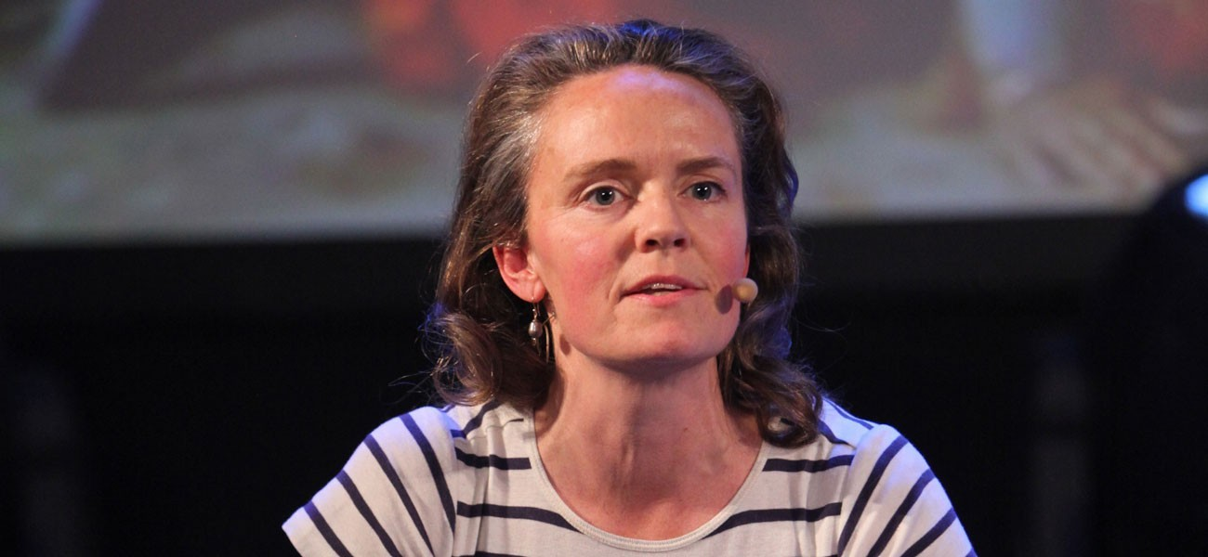

Justine Hardy is a British journalist, author, and conflict trauma therapist specializing in South Asia, and the Kashmir region in particular. She is the author of six books, ranging from journeys through Tibet, Hindi film, her time working at an Indian newspaper, the realities of orthodox Islam, and war. In 2005, Hardy published “The Wonder House,” a novel that explores the conflict in Kashmir based on her own experience reporting on the frontline and time spent both in militant training camps and amongst religious extremists. “The Valley of Mist,” published in 2009, is a non-fiction study of one family’s experience of living in Kashmir during the insurgency.

Hardy has contributed to the BBC, the Financial Times, The Times, Traveler, and Vanity Fair. As a writer and journalist, Justine has reported on South Asia for more than 25 years. Her journalism ranges from reports on her travels in Europe, India, the United States, and the Caribbean, to book reviews and social affairs reporting. Among other topics, she has written articles on the search for peace and the mental health crisis in Kashmir, and on female activists within Islam.

In addition to her writing, Hardy is involved in several aid projects. In October 2005, following an earthquake in Kashmir, she worked with the Kashmir Welfare Trust, a local NGO responding to the devastation of the earthquake. Directly after the earthquake, basic shelters were built, blankets collected, and food and medical supplies were brought to the more remote areas of Kashmir Valley. Long-term projects were then instituted, such as home reconstruction and the establishment of a school and an orphanage for children who had lost their families in the earthquake. As a result of this work Hardy went on to set up Healing Kashmir in 2008, a mental health program that combines integrated mental health treatment and a suicide helpline.

Internship

Time frame: Mid-June to early July (approx. 3-4 weeks)
Location: Kashmir, India
Description: This internship will involve research and field work with Professor Justine Hardy in Kashmir. Based out of the Institute of Global Leadership, this internship will focus on the study of how conflict affects societal norms and the process of rebuilding infrastructure post-conflict. Open primarily to rising junior and seniors, the ideal candidate will have excellent writing skills, experience in field work, and an interest in psychology. Due to the challenges involved in working in a conflict zone, the intern should be prepared for the limitations involved with study in Kashmir and be comfortable adapting to the restrictions of everyday life. Justine will be on the Tufts campus from spring break until the end of May, and is available to meet with the scholar during this time as well.

Srdja Popovic

Srdja Popovic is a founding member of Otpor!, the Serbian civic youth movement that played a pivotal role in the ousting of Slobodan Milosevic. He is a prominent nonviolent expert and the leader of CANVAS, a nonprofit organization dedicated to working with nonviolent democratic movements around the world. CANVAS works with citizens from more than 30 countries, sharing nonviolent strategies and tactics that were used by Otpor!.

A native of Belgrade, Popovic has promoted the principles and strategies of nonviolence as tools for building democracy since helping to found the Otpor! movement . Otpor! began in 1998 as a university-based organization; after only two years, it quickly grew into a national movement, attracting more than 70,000 supporters. A student of nonviolent strategy, Popovic translated several works on the subject, such as the books of American scholar Gene Sharp, for distribution. He also drafted speeches and wrote manuals to train Otpor! activists in nonviolent action.

After the overthrow of Milosevic, Popovic served in the Serbian National Assembly from 2000 to 2003. He served as an environmental affairs advisor to the prime minister. He left the parliament in 2003 to found CANVAS. The organization has worked with people in 46 countries to transfer knowledge of effective nonviolent tactics and strategies. It has aided numerous movements around the world, such as the Georgian “Rose Revolution" in 2003, and the April 6th movement in Egypt. CANVAS also produced a handbook for activists, “Nonviolent Struggle: 50 Crucial Points,” which is available in six languages, including Arabic and Farsi, and has been downloaded more than 20,000 times.

Popovic appears in two award-winning documentaries, “Bringing Down a Dictator” and “How to Start a Revolution.” In 2011, Foreign Policy named Popovic one of the Top 100 Global Thinkers. In 2012, Wired included him on its Smart List of “50 people who will change the world."

About CANVAS:

The Center for Applied Non-Violent Action and Strategies (CANVAS) is a non-profit, non-governmental, international network, oriented to educational work related to strategic nonviolent conflict. CANVAS founders were part of the team that organized a successful nonviolent movement, which lead to the overthrow of Serbian dictator Slobodan Milosevic. Our mission now is to reach widest possible international audience, in order to share experiences and learn more on strategic nonviolent conflict spreading this knowledge to future generations.

Internship

Time frame: Mid-June to late August (approx. 10 weeks)
Location: Belgrade, Serbia
Description: This internship will primarily involve analytical research for Srdja Popovic’s NGO CANVAS, which focuses on a multitude of social movements all around the world. The CANVAS Analytical Research Intern will primarily work on situation research and analysis for the countries where the CANVAS team is working, but duties are subject to change depending on current needs and ongoing projects.
Intern duties have also included:
- social media management
- drafting articles for English language publications
- region-specific analyses and research
- transcription of videos
- tracking news stories
- inventory of publications

The intern must be a strong writer in English. Knowledge of another foreign language is a plus.
*Please also see internship description provided by CANVAS

